Title: Times New Roman, 14, Bold. Use Title Case

First AUTHOR¹, Second AUTHOR², Third AUTHOR³
¹First author affiliation
²Second author affiliation
³Third author affiliation
First author email, Second author email, Third author email

This document gives formatting instructions for authors preparing papers for publication in the Database Systems Journal. In the abstract, please describe your paper using between 100 and 150 words. Use Times New Roman, 12, italic font style. The authors must follow the instructions given in the document for the papers to be published. You can use this document as both an instruction set and as a template into which you can type your own text.
Keywords: Keyword1, Keyword2, Keyword3, Keyword4, Keyword5

1Introduction
The paper shall include an introduction on the current research in the papers field, original solutions, experimental results analysis, conclusions and references.
The paper should be edited as Microsoft Word2003/2007(Microsoft) (or equivalent Word Processor, with the following settings (all measures in centimeters):
- Page setup: Page size A4, orientation portrait; Margins: mirror margins, top 3cm, bottom 2cm, inside 2.5cm, outside 2cm, gutter 0.5cm; Layout: header 1.7 cm (different odd and even), footer 0cm, section start continuous, page alignment top;
- Page numbers: top, outside, font Times New Roman size 10, bold, continue from previous section;
- Paragraph format: line spacing single, uncheck widow/orphan protection, alignment justify;
- Font: Times New Roman size 12, regular (unless otherwise stated in the following sections);
- Document language: English (US/UK), automatic hyphenation on (hyphenation zone 0.1cm). Make sure the speller has been used to correct eventual typing mistakes.
Use the following settings for title, authors, abstract and keywords:
- Paper title: centered paragraph, font size 14, bold, Title Case.
- Author(s): full name (last name all capitals), and affiliation (institution, city, country, email) – centered paragraph. Author names must not show any professional title (e.g. Director), any academic title (e.g. Dr.) or any membership of any professional organization. Each affiliation must include, at the very least, the name of the university / company, the name of the city and the name of the country where the author is based (e.g. Academy of Economic Studies, Bucharest, Romania).
- Paper abstract: describe your paper using between 100 and 150 words. Use italic font style.
- Keywords: italic font, the lead word “Keywords” also with bold font.
Each paper shall have no less than 10 pages and no more than 15 pages (using this format). Shorter papers are allowed only in the following situations: announcements for scientific events (congresses, seminars etc.), book reviews.

2 Content details
For regular text use Times New Roman, normal, size 12. For section names use New Roman, bold, size 12.
Figures and tables must have descriptive titles and consecutive numbering, respectively.
Figures and tables must be numbered using Arabic numerals. Figures and tables must be centered.
All figures, pictures and similar objects must be included in objects of type Microsoft Word Picture and centered. Table description is placed above them; picture description is placed below them. Description of pictures and titles must begin with type identification and number (e.g.: Fig. 1. or Table 1. – using bold font; description uses regular font). Each pictures or table must be placed as close as possible to the first reference in the text. Layout for each object must be “in line with text”. Insert figures and tables after they are cited in the text.
Place figures and tables at the top and bottom of columns. Avoid placing them in the middle of columns. Large figures and tables may span across both columns.

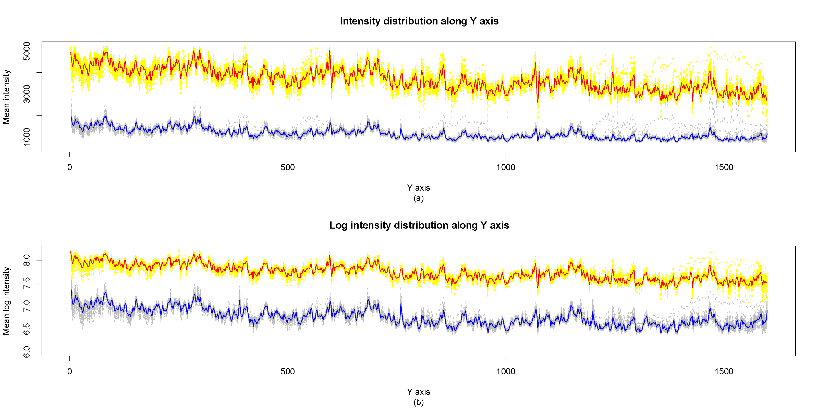

Fig. 1. Example

Please check all figures in your paper both on screen and on a black-and-white hardcopy. When you check your paper on a black-and-white hardcopy, please ensure that the colors used in each figure contrast well, the image used in each figure is clear and all text labels in each figure are legible.
Table 1 present details of the paper content, which must be respected in order to be published.

Table 1. Content details
Content | Details
Paper title | Centered paragraph, font size 14, bold.
Author(s) | Full name (last name all capitals) and affiliation (institution, city, country, email) – centered paragraph.
Paper abstract | Describe your paper using between 100 and 150 words. Use italic font style.
Keywords | Italic font, the lead word “keywords” also with bold font.
Content | Describe original solutions and experimental results analysis.
References | Use IEEE Citation Style. Use numbers enclosed in square brackets for each reference. All references have to be cited within the paper; otherwise they will be removed from the reference list.

All figures and tables must be referred in the paper.
Source code: if the paper includes sections of source code, it should be written with Courier New font, size 9, bold and properly indented, as in the following example:

http://rau/test.cgi?a=1
http://rau/test.cgi?a=1’
-> SQL Injection
http://rau/test.cgi?a=<script>…
-> Cross-site Scripting (XSS)

All hypertext links and section bookmarks will be removed from papers during the processing of papers for publication. If you need to refer to an Internet email address or URL in your paper, you must type out the address or URL fully in Regular font.

3 References, citations and authors descriptions
Citations: use IEEE Citation Style: numbers enclosed in square brackets (e.g.: [1], [2], [33]).
References: use IEEE Citation Style. Use numbers enclosed in square brackets for each reference.
Reference numbers are set flush left and form a column of their own, hanging out beyond the body of the reference. The reference numbers are on the line, enclosed in square brackets. In all references, the given name of the author or editor is abbreviated to the initial only and precedes the last name.
References may not include all information; please obtain and include relevant information. Do not combine references. There must be only one reference with each number. If there is a URL included with the print reference, it can be included at the end of the reference.
In the References section are presented references to a paper in proceedings [1], to an article [2], to a book [3] and to an online journal article [4].
Citations should be numbered in the order they appear in the text. All references must be detailed in the Reference/Bibliography section. Avoid using footnotes, as they may interfere with final formatting of the paper.
All references have to be cited within the paper; otherwise they will be removed from the reference list.
For each author include a small face picture (3 x 2.5 cm) and a short description including (but not limited to): affiliation, education, research field(s). The authors’ description is mandatory for the papers to be published.

4 Reviewing process
All papers will be subjected to peer review and are expected to meet standards of academic excellence. A blind review process will be used, employing 2 or 3 scientific reviewers. Author(s) will be notified about the outcome via email, using the declared address.
An author may not publish more than two papers per year in the Database Systems Journal. The bibliography and references must comply with the above requirements. These are the eligibility criteria for the assessment process.

5 Conclusions
Paper should end with conclusions.

6 Acknowledgment
The preferred spelling of the word “acknowledgment” in America is without an “e” after the “g”. Put applicable sponsor acknowledgments here; DO NOT place them on the first page of your paper or as a footnote.

References
[1] I. Lungu, G. Sabau, M. Velicanu, M. Muntean, S. Ionescu, E. Posdarie and D. Sandu, Information Systems Analysis, Design and Implementation, Ed. Economica, Bucharest, 2003.
[2] R. Bologa, A. R. Lupu and G. Sabau, “Digital Fluency And Its Importance In Educating Young Students For The Knowledge Age,” Proceedings of the 7th WSEAS Int. Conf. on Distance Learning and Web Engineering, pp. 354-457, Beijing, China, 15-17 September 2007.
[3] A. R. Lupu, R. Bologa, G. Sabău and M. Muntean, “Integrated Information Systems in Higher Education,” Wseas Transactions on Computers, Vol. 7, Issue 5, May 2008, ISSN 1109-2750, pp. 473-482.


Ion LUNGU graduated from the Faculty of Cybernetics, Statistics and Economic Informatics of the Academy of Economic Studies in 1974. He got the title of doctor in economy in the specialty economic informatics in 1983. He has been directing graduates who study towards getting a doctor’s degree since 1999. At present he is a professor in the department of the faculty of Cybernetics, Statistics and Economic Informatics of the Academy of Economic Studies of Bucharest. He had documentary activity and specialisation with the Eindhoven Technical University of Holland, the Economic University of Athens and Economic University of Milan. His domains of work are: informatics systems and databases. Among his books are: "Databases, organization, design and implementation", (1995), "Information Systems for Management" (1994), "SGBD Oracle Applications" (1998); "Let’s learn Oracle in 28 lessons” (2003), "Database systems" (2003), "Information Systems – Analysis, Design and Implementation" (2003).

